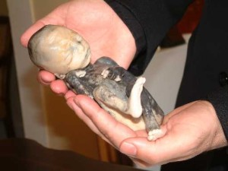
A fetal victim of instillation abortion.
Am J Obstet Gynecol. 1975 Jul 1;122(5):549-54.

Response of the primate fetus to intra-amniotic saline injection.
Comas-Urrutia A, Adamsons K, Myers RE.

Abstract
The amniotic fluid was replaced with 20 per cent sodium chloride solution during the second half of gestation in 12 pregnant rhesus monkeys. This produced a congealing of the fetal blood in the small umbilical vessels which overlie in the placental chorionic plate. Death of severe asphyxia followed within 20 to 50 minutes in the younger fetuses due to a prompt cessation of umbilical blood flow. During this time, the rise in serum sodium of the fetus was moderate and could not be implicated as the cause of fetal death. In older fetuses, the asphyxia produced by the saline injection was transient and less severe, occasionally permitting survival. The caliber of the affected fetal umbilical blood vessels and their blood flow rates are presented as the principal determinants of the rapidity of development and the severity of the asphyxia produced by saline instillation.

